United Nations Development Programme
Country: Suriname

Project Document

Feasibility study of the commercial production of biofuels from dedicated biomass crops on mined-out bauxite lands in Suriname

UNDAF Outcome(2): | By 2016, government formulates and implements harmonized, equity focused, and gender sensitive MDG-oriented key legislation, policies, and budgets in accordance with the government’s commitments to international human rights conventions and other internationally agreed development goals.  By 2016, most excluded, marginalised groups and vulnerable populations benefit from reinforced social, economic, and environmental programmes towards accelerated and equitable MDG progress, meaningful participation, and a better quality of life for all beyond the MDG agenda.
Expected CPD Outcome(s):  (Those linked to the project and extracted from the CPAP) | By 2016 public and relevant national-level institutions are strengthened and possess the institutional capacities, management instruments, policy frameworks and competencies to: promote environmentally sustainable development; adapt to and mitigate the impacts of climate change on the most vulnerable; and prepare for and empower vulnerable communities to respond to natural disasters and other anthropogenic-induced hazards.
Expected Output(s):  (Those that will result from the project and extracted from the CPAP) | Contribute to environmental conservation and prudent management of the Country’s environmental resources, whereby the national institutional capacities, policy frameworks and environmental strategies will be improved.  Improve the quality of life and the standards of living of the targeted vulnerable communities through the creation of employment and economic activities.
Implementing Partner: | Ministry of Natural Resources
Responsible Parties: | Caribbean Renewable Oils Partners (CROP) for Component 1 and 2.  Ministry of Natural Resources (NH) for Component 3.

Brief Description

The primary goal of the feasibility study, which is supported by pilot scale activities, is to establish the agronomic and techno-economic viability of Arundo donax plantations within the mined-out areas of the Moengo region, as well as to assess the socio-economic and environmental impact that commercial-scale implementation of the project will have on the region. The Arundo donax will be converted through thermochemical conversion processes into solid and liquid biofuels.
The pilot scale activities of the project will be conducted in partnership with SURALCO as part of their remediation actions and will seek to restore the ecological integrity of the in areas selected twenty (20) hectares of mined-out bauxite lands.

The feasibility study includes three major components:
- Assessments of agricultural activities including the pilot demonstration of an Arundo donax farm in Moengo (earmarked by SIDS DOCK intervention);
- Assessments of technical and economic activities;
- Management support (earmarked by SIDS DOCK intervention) and Policy support.

The requested financial assistance from SIDS DOCK based on the first and (part of the) third component of the feasibility study amounts to USD 250,000. After successful completion of the first component, the outcomes as expected are to (a) have a sufficient uniformity in soil to allow for representative sampling, (b) have political and local support to include the willingness of stakeholders to give accurate information, (c) have identified areas for test farms and (d) improve the environmental design of the project and have accurate GHG calculations and farm records.

Programme Period: 2013-2015 (18 months)

Key Result Area (Strategic Plan): Renewable Energy

Atlas Award ID: 00071972

Start date: December 2013
End Date June 2015

PAC Meeting Date August 6, 2013

Management Arrangements NIM
Total resources required: 730,000
Total allocated resources:
- SIDS DOCK 250,000
- UNDP 30,000

- Other parallel co financing :
- CROP 169,000
- SURALCO 50,000
- Bourne Consulting 61,000
- Technology Partners 170,000
- Gov’t inkind contribution

Agreed by (Implementing Partner): Minister Jim Hok of Natural Resources

Agreed by UNDP: Dr. Richard Blewitt, Resident Representative UNDP in Suriname

Table of Content

Acronyms 4
1. Situation Analysis 5
1.1 Background and Context 5
1.2 Policy context 5
1.3 Role SIDS DOCK 6
2 Project Strategy 7
2.1 Potential in Biofuels 7
2.2 Feedstock option: Arundo donax 7
2.3 Technology context 8
3 Sustainability 9
3.1 Renewable energy 9
3.2 Ecosystem Rehabilitation 9
3.3 Climate Change impacts 9
3.4 Sustainable Livelihoods 10
4 Outputs and Activities Feasibility Study 11
4.1 Towards a Biofuels Policy 11
4.2 Outputs within the feasibility study 11
4.3 Activities 15
5 Management Arrangement 17
5.1 Project implementation 17
5.2 Organizational Structure 17
5.3 Responsibilities of the parties 19
5.4 Audit arrangements 21
6 Monitoring Framework and Evaluation 22
6.1 Cost of Project Management, Monitoring and Evaluation 23
6.2 Quality Management for Project Activity Results 23
7 Financial Plan & Workplan 26
8 Legal Context 30

ANNEX I 31
Memorandum of Understanding 31
ANNEX II 32
Terms of Reference ‘Project Coordinator’ 32
ANNEX III 33
Draft TOR consultant Biofuels Strategic framework 33

Acronyms

BUZA | Ministry of Foreign Affairs
CARICOM | Caribbean Community
CER | Carbon Emission Reduction
CPAP | Country Programme Action Plan
CROP | Caribbean Renewable Oils Partners
5C’s | Caribbean Community Climate Change Centre
DC | District Commissioner
EIA | Environmental Impact Assessment
EMP | Environmental Management Planning
GDP | Gross Domestic Product
GHG | Greenhouse gas
GIS | Geographical Land Information System
IADB | Inter-American Development bank
IICA | Inter-American Institute for Cooperation on Agriculture
LoI | Letter of Intent
LVV | Ministry of Agriculture, Livestock and Fisheries
MDG’s | Millennium Development Goals
M&E | Monitoring and evaluation
MOU | Memorandum of Understanding
NH | Ministry of Natural Resources
NIM | National Implementation Modality
NIMOS | National Institute for Environment and Development in Suriname
PDF | Project Development Facility
PEP | Project Executing Partners
PFD | Process Flow Diagram
RO | Ministry of Regional Development
ROGB | Ministry of Physical Planning, Land and Forest Management
SBAA | Standard Basic Assistance Agreement
SIA | System Impact Assessment
SIDS | Small Island Developing States
SURALCO N.V | Suriname Aluminium Company
SWOT | Strengths, Weaknesses, Opportunities, and Threats
UNASUR | Union of South American Nations
UN | United Nations
UNDAF | United Nations Development Assistance Framework
UNDAP | United Nations Development Assistance Plan
UNDP | United Nations Development Programme
US | United States
VIDS | “Vereniging van Inheemse Dorpshoofden in Suriname”  (Assembly of Indigenous Chiefs in Suriname)

Situation Analysis

Background and Context
Suriname has up till now no biofuels policy, but the country has ambitions to develop one.
In doing so, Suriname has requested support from several international multilateral organizations, including the UN Economic Commission for Latin America and the Caribbean and the Inter-American Development Bank.
Suriname is thus in the process of developing a sustainable energy sector to serve as a foundation for the development of a low carbon economy. The signing of several Bilateral and Technical Cooperation Agreements by the Government of Suriname has served to reinforce the Government’s commitment to the development of renewable energy and provides the requisite level of comfort for foreign investment in the sector. Suriname’s sustainable development aspirations, including those agreed to and elaborated within the framework of the Millennium Development Goals (MDGs) and the Millennium Declaration, also speak to the need and importance of focusing on expanding bio-fuels production and use.

Policy context
The Government of Suriname has recently entered into a comprehensive Memorandum of Understanding with the Government of Brazil which will promote the production and use of bio-energy in both countries as well as to establish a basis for the two countries to work together in various regional and multilateral forums for the development of an international biofuels market.

Such actions by the Government of Suriname are entirely complementary with private sector-led actions, and positions Suriname at the cornerstone of Regional Biofuels development within both the South American (UNASUR) and Caribbean (CARICOM) regional configurations. In fact both the PETROCARIBE Agreement (Clause III on Mixed Companies) and the Suriname-Brazil MOU on Bio-fuels, admits to private sector participation in central areas.

The multilateral institutions (IADB, World Bank, International Monetary Fund, and various UN bodies), have also revisited and revised their policy positions on public-private partnerships, which is now viewed as the preferred model for cooperation and a prerequisite for sustainability in developing countries.

A biofuel project will make a significant contribution to the realization of Suriname’s Sustainable Development aspirations, including those agreed to and elaborated within the framework of the 2015 Millennium Development Goals (MDG’s) and the Millennium Declaration. For the new Government of President Bouterse, which came into Office in May 2010 with a mandate to, among other things, combat poverty, foster economic and social development for all, including those in the interior, is this also an indispensable element in realizing the Development aspirations.

Role SIDS DOCK

SIDS DOCK primary purpose is to facilitate the development of a sustainable energy economy within the SIDS. SIDS DOCK facilitates the funding through a combination of sources including the SIDS themselves (government, private sector, social organizations), and the global private sector and development partners.
Regarding this biofuel project, the requested funding will be provided by the Government of Denmark. The Danish government prefers to supporting innovative and climate friendly biofuel projects, which aim to stimulate local economic growth (including employment) and social development. This project fully takes into account the Danida guide: Biofuels - sustainability assessment of development aid programmes and projects, July 2011 and as appropriate aims to comply with the EU guidelines on Biofuels.

Project Strategy
There are at least five (5) themes which underpin energy policies within CARICOM States, including Suriname:
(a) Universal access to sustainable and secure energy supplies;
(b) Relationship to energy and international competitiveness of domestic and regional industries;
(c) Economic and social transformation and diversification of the economy through energy security;
(d) Optimization of the domestic production of energy in an environmentally sustainable manner; and
(e) South-South Cooperation for trade and development.

Suriname is in the process of revisiting its approach to foreign policy and international cooperation, so as to accord a greater focus to South–South Cooperation. There is an organic relationship between Suriname’s development priorities, its prospects for South-South trade and cooperation, and the country’s enormous potential in biofuels.

Potential in Biofuels
Suriname is endowed with many natural resources including soil, water, forests and mineral ores. Its economy is dominated by the mineral and energy sectors (gold, oil, and alumina) which account for approximately 30% of its GDP. It is expected that at current rates of production, the supply of these resources can be exhausted in the future. Consequently, alternative economic activities are being evaluated with a view to developing a sustainable replacement for the industry.

The repositioning of Suriname’s foreign policy and international cooperation can act as an important stimulus to the attainment of its development objectives, through initiates such as the proposed bio-fuels project by the Caribbean Renewable Oils Partners (CROP) N.V, born out of the shared experiences of the Caribbean SIDS toward renewable energy development. They initiated the following project: ‘Exploration of the commercial production of dedicated fuel crops in the mined-out area for potential development between 2013 and 2015’.

The partnership between the Government of Suriname and CROP seeks to utilize 10,000 hectares of the available 32,000 hectares of mined-out bauxite lands in the Moengo region of eastern Suriname for the commercial farming of biomass. At this juncture, the Government of Suriname and its project partners are desirous of conducting studies on the agronomical, logistical, economic and socio-environmental feasibility for this initiative. The pilot studies will be done on 20 hectares of mined-out lands within the Moengo region of eastern Suriname and in partnership with Suriname Aluminium Company (SURALCO) N.V. The feasibility study will be implemented over a period of eighteen (18) months with CROP as the responsible partner executing the project.

Feedstock option: Arundo donax
Based on research and local knowledge, a profilic lignocellulosic plant, Arundo donax, has been identified by the project partners as the best crop suitable to the soil and climate conditions in the mined-out areas in eastern Suriname. Arundo donax is being targeted as the feedstock for biofuel production in this project because of its advantageous properties.

Arundo donax is a stout perennial grass, with thick, short, branched rhizomes. Adapted to tropical, subtropical and warm temperate climates of the world, the plant is most often found on sand dunes near seashores (and tolerates most salt). It grows best along river banks and in other wet places, and is best developed in poor sandy soil, in sunny situations and has been known to tolerate all types of soils; from heavy clays to loose sand and gravelly soils. The grass species is very hardy and needs virtually no fertilizers, nor any other means of protecting the crop with herbicides during its growth. It is propagated by divisions of the stout rhizomes, planting these where new plants are desired and is easily established. The grass may be harvested mechanically and is suited to existing grasslands and pastures, and can be utilized towards the re-establishment of agricultural activities in “mined out” bauxite lands.

Technology context
The project partners have secured access to mature technologies for the establishment of large commercial acreages of Arundo donax. The project partners have also procured the commercial rights to processing technologies for the conversion of thermochemical conversion of lignocellulosic biomass into biofuel products with high portability and high energy density; inter alia, bio-oil and torrefied pellets. The conversion of the biomass into bio-oil will be done within ‘contained piping and sealed equipment’ without emissions, through what is commonly referred to as a “closed loop pyrolysis” system. As such each process has the inherent ability to avoid emissions of hazardous fractions and particulate matter and is environmentally benign. Densification or torrefication, is likewise, a process that produces no emissions. Consequently, the project is one that is expected to have positive local and global environmental balance due to the reduction in particulate matter, as well as nitrous and sulphur oxides on the local scale and the reduction of carbon dioxide on the global scale.

The production of bio-oil from Arundo donax via fast pyrolysis will serve to significantly enhance Suriname’s position as an exporter of energy within the region and will run complementary to the fledging fossil economy, as well as other renewable interests. In particular, the robustness of the energy crop, Arundo donax, makes it particularly resilient against climate and weather shocks, such as droughts, etc. and consequently hedges against the risk associated with the more demanding feedstocks such as sugar cane and sunflower.

Sustainability

Renewable energy
Given the combined significance of the power generation and transport sectors toward current and projected global fossil fuel demand (around 69 per cent), targeted substitution by biofuels can only be deemed successful if applicable to both. An integral approach between first generation biofuels, which is obtained through transesterification of oils (biodiesel) and sugar fermentation (bioethanol) and second generation biofuels from pyrolysis techniques (bio-oil) will provide a sustainable platform for sustainable commercial biofuels production in Suriname. In fact, the flexibility of bio-oil as a direct replacement for liquid fuels in electricity generation and as a potential replacement for significant automotive diesel makes it a rather attractive option.
The cultivation and extraction of oil from Arundo donax represents an important renewable energy alternative to the use of fossil fuels for the transport and other sectors.
Arundo donax is a strong candidate for use as a renewable biofuel source because of its rapid growth rate, and ability to grow in different soil types and climatic conditions. Studies in the European Union have identified Arundo donax as the most productive and lowest impact of all energy biomass crops (FAIR REPORT). The ability of the Arundo donax plant to grow for 20 to 25 years without replanting is also significant.

Ecosystem Rehabilitation
The land under concession to the Suriname Aluminium Company (SURALCO) N.V is approximately 32,000 ha of which 10,000 ha will be utilized for the commercial farming of biomass. For the feasibility study 20 hectares of mined out land will be used. SURALCO is the local subsidiary of Alcoa, the world’s leading producer of primary aluminum and fabricated aluminum, as well as the world’s largest miner of bauxite and refiner of alumina. Alcoa has proposed a major rehabilitation exercise with mined-out bauxite lands in the Moengo area of eastern Suriname. According to Alcoa, “rehabilitation implies that the mined-out site is returned to a stable condition that will not deteriorate substantially, but will be consistent with the aesthetic, environmental, economic and social values of the surrounding land”. Currently SURALCO has undertaken the physical re-conditioning of the mined-out areas and expects to continue the process for the next 3 to 5 years. In restoring the former top soil layer, care has been taken to approximate fertility levels for re-starting the production, reforestation or even natural regeneration processes.
The feasibility study will contribute to efforts to rehabilitate the lands by assuring, sustainable land management and the study will seek to promote conservation, environmentally-friendly interventions. Important is the use of technology protocols that not only successfully rehabilitates the mined-out lands, but will also reduce poverty and enhance the socio-economic well being of the region through participation of the local population in local businesses, CBOs etc.

Climate Change impacts
The Government of Suriname is looking for ways to mitigate climate change, ensure energy security, strengthen the agricultural sector and promote development. At present, there is a lack of real alternatives to help reduce GHG emissions or over-dependence on fossil fuel in the transport and other sectors, which reinforces the importance of developing biofuels production in as sustainable a way as possible. The sustainable production of biofuels, which is proposed herein, delivers a positive contribution to the reduction of GHG emissions. In most instances, attempts have been to supply energy through biomass focused on ethanol production through the use of food crops such as corn (US) and sugarcane (Brazil). This has had a negative impact on global food supply and has led to mass resentment towards biomass projects on the whole. The utilization of a non food crop that is capable of growing on marginal (non agricultural) lands without significantly compromising the availability of water for the irrigation of food crops is deemed to be desirable.
On the local level, the products of the study will be capable of significantly reducing the exhaust (particulate, nitrous and sulphur) emissions that are associated with the conventional fuels through the replacement of traditional fossil fuels with biofuels. Moreover, these products integrate suitably into the current electricity generation infrastructure.

Sustainable Livelihoods
It is well-recognized that the social pillar is of key importance in the transition to a more socially-inclusive and sustainable green economy. Therefore partnerships will be forged with local communities. CROP will provide technical assistance for the development of community-based projects in activities like small scale biodiesel production from plant oils, exotic soap manufacturing from glycerol and essential oils, as well as other identified areas of local interest. There is also a tacit commitment to invest ten percent of the operating profits of the company in development projects. This will be split evenly between the local Moengo region and the wider Suriname.

Outputs and Activities Feasibility Study
The feasibility study is aimed at examining the feasibility of establishing commercial scale Arundo donax plantations within Suriname; it is anticipated that the biomass produced will be utilized toward the manufacture of a number of biofuels through thermochemical conversion processes.
The feasibility and pilot scale activities will be conducted over an eighteen (18) month period – October 2013 to April 2015– and is seeking to establish the agronomic and techno economic viability of Arundo donax plantations within the mined out areas of the Moengo region, as well as the socio- economic and environmental impact that commercial scale implementation of the project will have on the region.

Towards a Biofuels Policy
In order to achieve the targets outlined in the Development Plan 2012-2016 and the Draft Suriname National Energy Policy 2013-2033 which includes a reduction in the use of petroleum and an increase in renewable energy, a strong demand exists to develop a Biofuels Policy in order to ensure institutional coherence and political willingness and commitment for creating a favourable investment climate and market condition.

The development of a Biofuels Policy will be preceded by a Biofuels Strategic Framework with which will set out the goals, strategies and actions necessary to facilitate the implementation of the yet to be developed Biofuels Policy. This shall be done in close collaboration with the Ministry of Natural Resources. The Biofuels Strategic Framework will respond to the directive of the Development Plan 2012-2016 and the Draft Suriname National Energy Policy 2013-2033.

To set up a Biofuels Strategic Framework, data from this feasibility project will inform the Biofuels Strategic Framework. The feasibility study will “link” symbiotically with other previous and on-going initiatives towards first-generation biofuel (bio-diesel and bio-ethanol) production. In addition, this will provide increased flexibility on feedstock input and product output, and serves to increase diversity in the Biofuels Strategic Framework.

Outputs within the feasibility study
The pilot scale activities of the project will be conducted in partnership with SURALCO as part of their remediation actions and will seek to restore the ecological integrity of the mined-out bauxite lands in areas selected; twenty (20) hectares of lands have already been earmarked by the Land Remediation Management Team for same. See Figure 2 (page 14).

In general, the ‘Arundo Donax’ biofuels feasibility study consists of fifteen (15) outputs, inter alia:
- Land Identification and Assessment
- Socio economic Impact Assessment SIDS DOCK intervention
- Feedstock Assessment
- Environmental Impact Assessment
- Biofuel Plant Facilities Planning
- Logistics and General Facilities Planning
- Market Assessment
- Economic Assessment
- Competitive Strategy Design
- Financial Planning
- Risk Assessment
- Project Management
- Monitoring & Evaluation SIDS DOCK intervention
- Auditing
- Biofuels Strategic Framework

Most of the outputs can be grouped into two major components within the feasibility study: (1) Agronomic aspects and (2) Technical and Economic aspects.
Cross cutting the whole feasibility study a third component can be identified: (3) Outputs regarding management support and policy support in developing the Biofuels Strategic Framework. Table I provides an overview of all the outputs within the three components of the feasibility study.

Components | Outputs
- Agronomic aspects (SoF SIDS DOCK) | 1.1 Land Identification and Assessment
- Agronomic aspects (SoF SIDS DOCK) | 1.2 Socio economic Impact Assessment
- Agronomic aspects (SoF SIDS DOCK) | 1.3 Feedstock Assessment
- Agronomic aspects (SoF SIDS DOCK) | 1.4 Environmental Impact Assessment
- Technical and economic aspects | 2.1 Biofuel Plant Facilities Planning
- Technical and economic aspects | 2.2 Logistics and General Facilities Planning
- Technical and economic aspects | 2.3 Market Assessment
- Technical and economic aspects | 2.4 Economic Assessment
- Technical and economic aspects | 2.5 Competitive Strategy Design
- Technical and economic aspects | 2.6 Financial Planning
- Technical and economic aspects | 2.7 Risk Assessment
- Management support (SoF Sids Dock) and Policy support (SoF UNDP, MNH) | 3.1 Project Management
 | 3.2 Monitoring and Evaluation
 | 3.3 Audit
 | 3.4 Biofuels Strategic Framework

Table I: Three components and corresponding outputs.

The SIDS DOCK intervention has been earmarked for the 1th and 3rd component, the Agronomic aspects and the Management support.

A pilot demonstration of an Arundo donax farm in Moengo will support the Component 1 ‘Agronomic assessments’. In particular, the agricultural outputs are delineated as follows:

1. Land Identification and Assessment
Based on the discussions with SURALCO thus far, it is anticipated that the field trials will be conducted on 20 hectares of designated pilot plots (in Jones 2), which may be linked to the remediation programme for same; this is in essence, a plan to “transition” the land from mining into productive commercial agricultural use. The selection of Arundo donax, a non food crop, for dedicated biofuel production is strategic as the crop is one of the few that is likely to thrive with limited input in the sandy-loamy-clay conditions of lands that have been significantly altered by mining; this activity is intended to survey the demonstration plot as well as delineate the “designated area” for the potential commercial project.
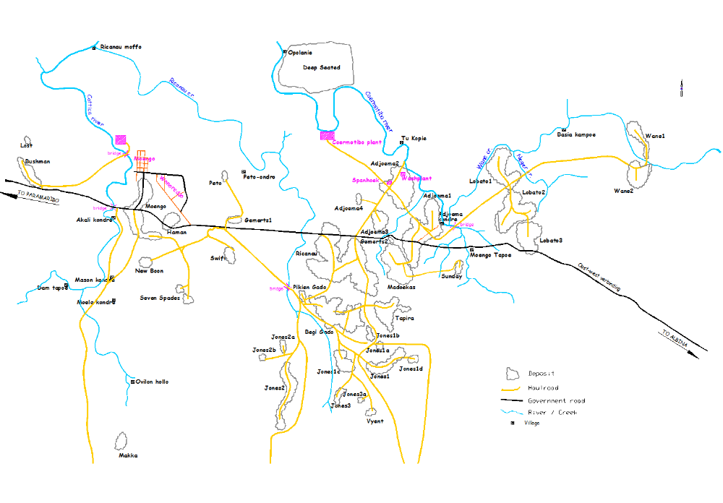

Figure 1: Designated Areas for Field Trials

This aspect of the study will include biological and chemical soil profiling, as well as physical assessment of the designated plots. A remediation plan will be developed so as to support the reliable, dedicated growth of Arundo donax for mechanical harvesting. The degree to which land levelling and deforestation activities are required will be assessed; the commercial production of the biomass crop requires large continuous tracts of homogenous lands with little or no slopes to support mechanized planting, management and harvesting. It is expected that this activity will be completed within the first eight (8) weeks of the project.

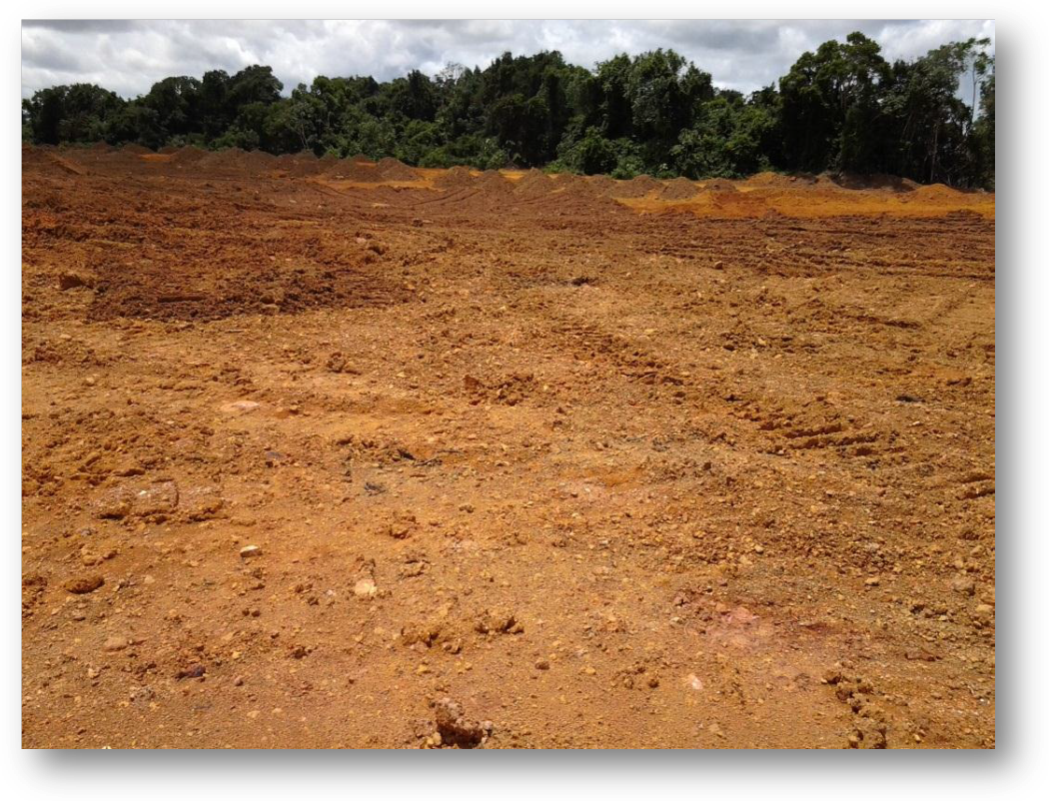
Figure 2: Mined out area in the designated plot (Jones 2)

2. Socio-economic Impact Assessment
Unlike the SURALCO project, which is based on a mining concession, the work that is being undertaken by CROP is based on a land lease for commercial-scale agricultural production. The suggestion therefore is for an early-stage Socio-economic Impact Assessment that includes Stakeholder Mapping and a second-round of community consultations.

Some of the important partners in this stage of the project include:
- At the level of the central government in Paramaribo, Ministry of Agriculture, Livestock and Fisheries (LVV); Ministry of Natural Resources (NH); Ministry of Regional Development (RO); and Ministry of Physical Planning, Land and Forest Management (ROGB). The Ministry of LVV and the Ministry of RO are deemed to be especially critical to the project given the agricultural focus on the one-hand and the location within an area where local and tribal rights issues are important.
(ii) At the level of the local community (Moengo), local authorities, such as the District Commissioner (DC) and local tribal leaders are deemed to be critical to the project success.

3. Feedstock Assessment
This is a critical project activity and is anticipated to establish the baselines on which the feasibility of the project will be based. This set of activities will include the establishment of and Arundo donax map for Suriname, through GIS survey, which will provide the location and varieties of the various species thereof. Large scale propagation of species will be conducted with Phyto-tech. Phyto-Tech will provide crop engineering services so as to produce around 60,000 plants per hectare, or around 600,000 plants in total (based 10 hectares of planted area within the designated area).

The study will establish a diverse set of Arundo donax plots within the 20 hectare plot so as to determine the rate of growth and yield per hectare that is obtainable for different varieties of soils with variation in biological and chemical properties.

The trial area will be divided into twenty (20) one hectare plots; combinations of Arundo donax varieties and remediation soil types will be investigated in order to determine the conditions under which optimum yield (dry biomass per hectare) is obtained. Pasture management techniques for containment of Arundo donax, such as barrier construction, will also be evaluated. The expectation is that this activity will be conducted over twelve (12) months and, at an average of 18 tons per hectare with bi-annual harvest, produce over 4,000 tons of biomass. Samples of the biomass produced will be packaged and exported to our technology partners for conversion efficiency and fuel quality tests. These tests – biomass yield, fuel conversion efficiency, and quality assessment – will form the techno- economic assessment on which the economic viability of the project will be based.

Farm Development will be critical to the success of the project. It was indicated that the intent is to start by mapping the existing varieties of Arundo donax that are currently proliferating within Suriname.

4. Environmental Impact Assessment
The establishment of Arundo donax, a dedicated biofuel crop on commercial plantations in Moengo, may have environmental implications. Agricultural plantations typically have inherent water demands and may, in instances, alter the ecological balance of surrounding areas. A full scale, independent Environmental Impact Assessment will be conducted to determine the ecological, carbon and water footprint of the project. The findings will be accompanied by an Environmental Management Plan (EMP) that is expected to guide commercial scaling of the project.

Activities
Table II gives an overview of the components that will take place within the feasibility study and their corresponding outputs and deliverables. Also an overview of all the activities from Components 1 (Agronomic aspects) and 2 (Technical and Economic aspects).

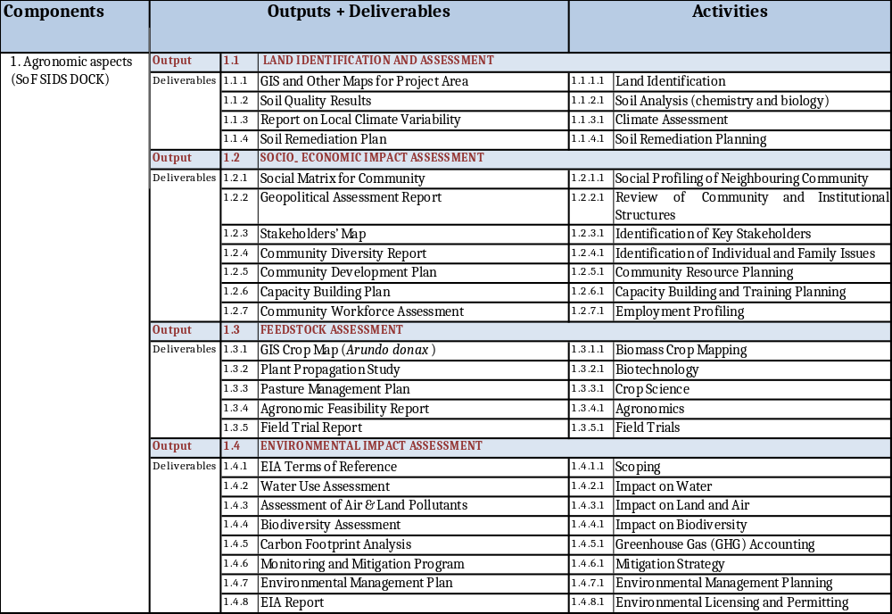
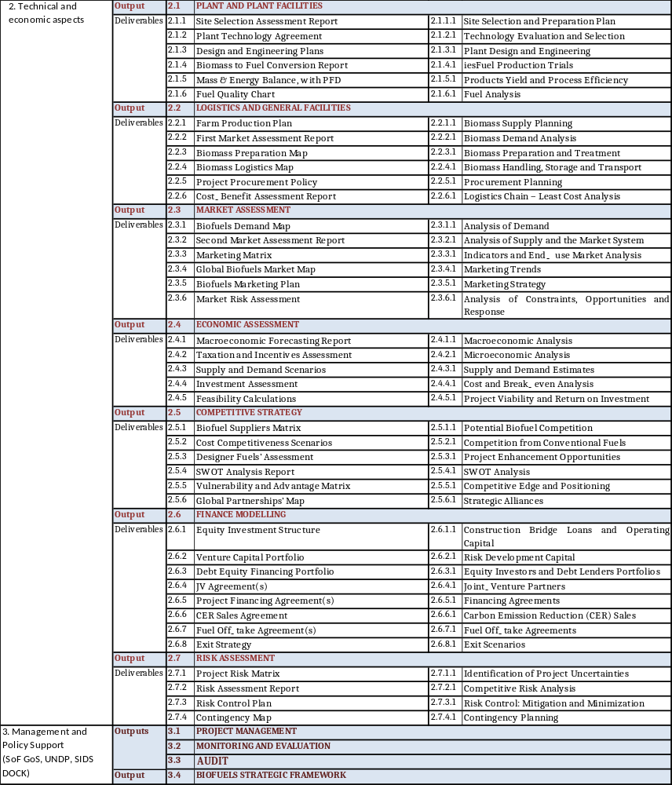

Table II: Overview of the outputs from the components that will take place within the feasibility study in correspondence with their deliverables and activities (except for component 3).

Management Arrangement

Project implementation
The feasibility study will be implemented over a period of eighteen (18) months beginning October 2013 and ending in April 2015. The feasibility study will be managed by CROP with whom the United Nations Development Program has signed a Letter of Intent (LoI) and a Memorandum of Understanding for partnership (Annex I).

The project will be implemented under National Implementation Modality (NIM) according to the standards and regulation for UNDP cooperation in Suriname. The Ministry of Natural Resources as Implementing Partner will sign the Project Document with UNDP and will be accountable to UNDP for an efficient and effective use of project resources and the achievement of the project goals, according to the approved agreement. The Project Responsible Party for component 1 and component 2 will be CROP. CROP will be responsible for implementation of the feasibility study. The Ministry of Natural Resources will be overall responsible for the execution of component 3 (including Policy support) and will control and monitor component 2 and component 3.
A Technical Advisory Committee will be formed that will include all major stakeholder entities and will provide guidance and oversight of project activities. The Technical Advisory Committee will provide (technical) advise to the Project Coordinator regarding the implementation of the project.

Organizational Structure
The project reporting structure will be in place starting from the beginning of the project. This will give a clear view of the status of the project, deliverables and responsibilities of parties. The following figure outlines the Project Organisation Structure (figure 3) and the Project Management Structure for components 1 and 2 (figure 4).

Figure 3: Project Organisation Structure
Project Coordinator (NH)

Project Board
Senior Beneficiary
Ministry of Agriculture, Animal Husbandry and Fisheries (LVV) P
Implementing Agency
Ministry of Natural Resources (NH)

Senior Supplier
UNDP/ SIDS DOCK/ 5C’s
Technical advisory Committee
Ministry of Natural Resources
Ministry of Foreign Affairs
Ministry of LVV
IICA
Suralco
UNDP (Suriname)

Component 3
Management + policy support

Project Organisation Structure
CROP
Field Coordinator
Feasibility study

Component 1
Agronomic aspects
Component 2
Tech/Econ aspects

Project Coordinator
(NH)

CROP
Field Coordinator

Technical
Consultants

Farm Manager

Admin & Logistics
Manager

Farm
Labourers

Farm
Contractors

Admin Asst.

& Clerk

Accountant

Figure 4: Project Management Structure components 1 + 2 (Agronomic aspects + Technical and Economic aspects)

Responsibilities of the parties

Parties | Responsibilities
Project Board | - Oversees and direct project implementation in conformity with the project implementation modality.  - Plays a critical role in project monitoring and evaluations. It ensures that required resources are committed and arbitrates on any conflicts within the project or negotiates a solution to any problems with external bodies. In addition, it approves the appointment and responsibilities of the Project Coordinator.  - Receives recommendations from the Technical Advisory Committee.
Technical Advisory Committee | - Informs and makes recommendation to the Project Board, through the Project Coordinator, of any delays or difficulties faced during implementation so that the appropriate support or corrective measures can be adopted in a timely fashion.  - Receives periodic reports from the Project Coordinator on progress.  - Provides reports to the CARICOM Climate Change Centre (5Cs), on a continuous basis and simultaneously keep the Government of Suriname informed of progress.  - Makes recommendations to the Project Board, through the Project Coordinator, concerning the need to revise any aspects of the Results Framework or the M&E plan.  - Progress, vis-à-vis delivering the expected data and assessments from the study, will be assessed with the Technical Advisory Committee at agreed intervals.  - Provides expert advice to the Project Coordinator and may provide technical input and recommendations to the Project Board. The main role of the Technical Advisory Committee is to review project achievements and guard the quality assurance of the project outcomes. Recommendations will be formulated and send to the Project Board.
Project Coordinator | - Day-to-day project monitoring.  - Send periodic reports on progress to the Technical Advisory Committee.  - Send recommendations from the Technical Advisory Committee to the Project Board.  - Keep the CROP Field Coordinator and the respective local stakeholders informed.
CROP Field Coordinator | - Is a representative of CROP, the Project Executing Partners (PEP)  - Have project oversight, to ensure that the project meets UNDP and SIDS DOCK policies and procedures.  - Review the quality of draft project outputs, provide feedback to the project coordinator, and establish peer review procedures to ensure adequate quality of scientific and technical outputs and publications.  - The emphasis will be on outcome monitoring but without neglecting the project financial management and implementation monitoring.
CARICOM Climate Change Centre (5Cs) | - Executor of the SIDS DOCK within the Caribbean.  - Monitor regularly project risks and assumptions; risk assessment and rating is an integral part of the review.
UNDP | - Collect specific information to track the monitoring indicators.  - Monitor regularly project risks and assumptions; risk assessment and rating is an integral part of the review.

Table III: Responsibilities of the parties

.

Audit arrangements
The Government of Suriname will provide the UNDP Resident Representative with certified periodic financial statements, and with an annual audit of the financial statements relating to the status of SIDS DOCK funds according to the established procedures set out in the Programming and Finance manuals. The Audit will be conducted by the legally recognized auditor of the Government, or by a commercial auditor engaged by the Government.

Monitoring Framework and Evaluation
Monitoring and evaluation (M&E) is a key component of the project. M&E systems will be developed for all project activities, with the requisite Project Indicators. The M&E system is designed to allow for the modification of the arrangements for each activity of the feasibility study so as to improve the effectiveness of the related tasks thereof. A specific budget to undertake this function has been established. The project will follow UNDP standard monitoring, reporting and evaluation processes and procedures. Project Progress Reports will be produced by the Executing and Implementing Parties as per the agreed Project Organisation Structure and will form the basis for review of progress and achievements by the Technical Advisory Committee, UNDP and SIDS DOCK (see chapter 5).
The Project Results Framework shall include indicators for each expected outcome as well as mid-term and end-of-project targets. These indicators along with the key deliverables and benchmarks will be the main tools for assessing project progress and to make determination on whether the expected results are being achieved. The means of verification are summarized in the Quality Management tables (table V to VIII).

The Evaluation Plan (table IX) will be reviewed and revised, as is deemed necessary during the Initiation Meeting, to ensure that the relevant stakeholders understand their roles and responsibilities vis-à-vis monitoring and evaluation; indicators and their means of verification may be fine-tuned at the inception meeting. The quality of project monitoring and evaluation will also include key financial parameters, which will be monitored quarterly to ensure cost-effective use of financial resources.

An independent Terminal Evaluation will take place at the end of project implementation. The UNDP will manage the terminal evaluation process. A review of the quality of the evaluation report will be done by the designated UNDP team and submitted along with the report to the UNDP Office not later than six (6) months after the completion of the evaluation. The time frame may be adjusted to meet any specific needs of the project.

The proposed Quality Management Matrices are attached below in tables V-VIII. These will be updated at midterm and at the end of the project and will be made available to the UNDP along with the Final Project Report. As mentioned above the terminal evaluation will verify the information of the Quality Management tables.

MONITORING and interim Technical EVALUATION of outcomes and Assessments | PARTNERS | PLANNED COMPLETION DATE | KEY EVALUATION STAKEHOLDERS | SOURCE OF FUNDING FOR EVALUATION | MANDATORY EVALUATION
Project
Farm Development  Pilot Demonstration | IICA | April 2015 | IICA;  5Cs;  Ministries of LVV NH & ROGB; SURALCO;  Local Leadership (Moengo) | Project Budget | Y
Fuel Production | N/A | April 2015 | 5Cs;  Staatsolie;  AdeKUS | Project Budget | N
Techno-economic Feasibility | N/A | April 2015 | 5Cs;  Ministry of BUZA | Project Budget | Y
Socio-economic Impact Assessment | N/A | April 2015 | Ministry of RO;  Local Leadership (Moengo),  NIMOS | Project Budget | Y
Environmental Impact Assessment | N/A | April 2015 | Ministries of NH, BUZA and ROGB, NIMOS;  Local Leadership (Moengo) | Project Budget | Y

Table IV: Evaluation Plan

Cost of Project Management, Monitoring and Evaluation
The Project is due to run for eighteen (18) months. As reported in the project budget, the total estimated cost specifically dedicated to both Project Management, Monitoring and Evaluation and Auditing is USD 35,000.

Project Management will be the responsibility of the Project Coordinator. This person will coordinate all activities within the feasibility study including financial management, risk assessment, communications, procurements, monitoring and general management activities. A total amount of 7,000 is budgeted for this activity.
The cost of project monitoring for all objectives/outcomes is estimated at USD 25,500. These costs will be financed under the SIDS DOCK contribution to the budget.
The evaluation is independent and shall be carried out by a project evaluation specialist that will be mandated by the Project Coordinator upon advice from the Technical Advisory Committee (with direct input from the 5Cs and UNDP); as planned, this will be carried out at the end of the project implementation. For auditing an amount of USD 2,500 will be dedicated.

Quality Management for Project Activity Results
The following tables provide information about the monitoring activities based on the first component ‘Agronomic aspects’. Within this Component 1 we can identify 4 outputs.

OUTPUT 1.1: Land Identification and viability assessed
Activity Result 1  (Atlas Activity ID) | •Field visits  •Soil sampling & geological testing  •Atomic Absorption Analysis |  | Start Date: (see workplan)  End Date:
Purpose | To determine the amount of sufficient uniformity in soil to allow for representative sampling
Description | •Physical map of project lands  •Biological & chemical profile of soil
Quality Criteria |  | Quality Method | Date of Assessment
•Amount of land levelling  •Amount of forest removal  •Amount & type of ions (in ppm)  •Soil type |  | Soil Quality Report  Soil Remediation Plan | Mid Term (July 2014)

Table V: Quality Management Output I.1

OUTPUT 1.2: Socio-economic impact assessed
Activity Result 1  (Atlas Activity ID) | •Field visits  •Stakeholder consultations & dialogues  •Surveys |  | Start Date: (see workplan)  End Date:
Purpose | To determine the social and economic impact on the vulnerable communities. Political and local support for the project, to include the willingness of stakeholders to give accurate information
Description | •Socioeconomic Profile, Moengo  •Stakeholder Map  •Capacity Building Strategy
Quality Criteria |  | Quality Method | Date of Assessment
•Labour force in Meongo  •Number of unemployed  •Number & type of “at risk” groups  •Number & type of stakeholders |  | •Consultations Report  •Stakeholders Map  •SIA Report  •Capacity Building Plan | Mid Term (July 2014)

Table VI: Quality Management Output I.2

OUTPUT 1.3: Viability of Feedstock assessed
Activity Result 1  (Atlas Activity ID) | •Farm Management  - Field Visits |  | Start Date: (see workplan)  End Date:
Purpose | Areas for test farms have been identified; support for remediation from SURALCO integrates with preparation
Description | •Arundo donax GIS Map  •Germplasms for five (5) Arundo donax species  •Biophysical land remediation, pilot plots  •Farm establishment  •Harvesting & Storage
Quality Criteria |  | Quality Method | Date of Assessment
•Number of natural Arundo donax species  •Amount & type of fertilizer per ha  •Plant height growth  •Yield per ha  •Cost per ha |  | •GIS Crop Map (A. Donax)  •Biotechnology Report  •Farm Manager Logs  •Field Trial Report  •Observations | Mid Term (July 2014) and at termination (April 2015)

Table VII: Quality Management Output I.3

OUTPUT 1.4: Environmental Impact assessed
Activity Result 1  (Atlas Activity ID) | - • Farm Management  - • GHG Calculations  - • Field Visits |  | Start Date: (see workplan)  End Date:
Purpose | To determine the Impact of project on the Environment.  •Accurate GHG calculations & farm records  •No seasonal variation
Description | •Carbon & Water Footprint Analysis  •Biodiversity Map
Quality Criteria |  | Quality Method | Date of Assessment
•Amount of water per ha  •Amount of CO2 produced  •No of species |  | •Farm Manager Logs  •GHG Calculations  •EIA Report | Mid Term (July 2015) and at termination (April 2015)

Table VIII: Quality Management Output I.4

Financial Plan & Workplan
The projected costs of the “Feasibility study for the Commercial Production of Biofuels from Arundo donax in Suriname” are estimated at a total of USD 730,000.
The amount requested from the SIDS DOCK as cash contribution is USD 250,000.
To advance the process, private partners are necessary to provide co-financing. Major potential donors are GTC International Ltd., Suriname Aluminium Company (SURALCO) N.V. and Staatsolie (State Oil Company of Suriname) N.V. The major partners, CROP and the Government of Suriname, will, along with their private sector partners, raise significant amounts of co-financing in-cash and in-kind (USD 480,000 or over 60 per cent of the project cost) to advance the process.

Table IX gives an overview of the total budget and workplan of the Feasibility Study.
ANNUAL WORK PLAN BUDGET SHEET
Year: 1

Components | EXPECTED OUTPUTS  And baseline, associated indicators and annual targets | PLANNED ACTIVITIES  List activity results and associated actions | TIMEFRAME |  |  |  | RESPONSIBLE PARTY | PLANNED BUDGET
Components |  |  | Q1 | Q2 | Q3 | Q4 | RESPONSIBLE PARTY | Funding Source | Budget Description | Amount (USD)
Component 1  Agronomic assessments  Baseline:  Indicators:  Targets:  outcome: |  | 1.0. Inception phase  - Appointment of PM  - Appointment of SC  - Inception workshop | X |  |  |  | NH, CROP | Suralco | NA
 | 1.1. LAND IDENTIFICATION AND ASSESSMENT | -Land Identification  - Soil Analysis (chemistry and biology)  - Climate Assessment  - Soil Remediation Planning | X |  |  |  | NH, CROP | CROP | NA | 50,000
 | 1.2. SOCIO- ECONOMIC IMPACT ASSESSMENT | - Social Profiling of Neighbouring Community  - Review of Community and Institutional Structures  - Identification of Key Stakeholders  - Identification of Individual and Family Issues  - Community Resource Planning  - Capacity Building and Training Planning  - Employment Profiling | X | X |  |  | NH, CROP | CROP | NA | 28,000
 | 1.3. FEEDSTOCK ASSESSMENT | - Biomass Crop Mapping  - Biotechnology  - Crop Science  - Agronomics  - Field Trials | X | X | X | X | NH, CROP | SIDS Dock | 71200  71300  71600  72100  72200 | 30,000  40,000  20,000  100,000  25,000
 | 1.4. ENVIRONMENTAL IMPACT ASSESSMENT | - Scoping  - Impact on Water  - Impact on Land and Air  - Impact on Biodiversity  - Greenhouse Gas (GHG) Accounting  - Mitigation Strategy  - Environmental Management Planning  - Environmental Licensing and Permitting |  | X | X | X | NH, CROP | Bourne consulting | NA | 61,000
Component 2  Technical and economic assessments  Baseline:  Indicators:  Targets:  outcome: | 2.1 PLANT AND PLANT FACILITIES | - Site Selection and Preparation Plan  - Technology Evaluation and Selection  - Plant Design and Engineering  - Fuel Production Trials  - Products Yield and Process Efficiency  - Fuel Analysis |  | X | X | X | CROP | Technology partners | NA | 170,000
 | 2.2 LOGISTICS AND GENERAL FACILITIES | - Biomass Supply Planning  - Biomass Demand Analysis  - Biomass Preparation and Treatment  - Biomass Handling, Storage and Transport  - Procurement Planning  - Logistics Chain – Least Cost Analysis |  |  |  | X | CROP | CROP | NA | 55,000
 | 2.3 MARKET ASSESSMENT | - Analysis of Demand  - Analysis of Supply and the Market System  - Indicators and End-use Market Analysis  - Marketing Trends  - Marketing Strategy  - Analysis of Constraints, Opportunities and Response | NA | NA | NA | NA | CROP | CROP | NA | 15,000
 | 2.4 ECONOMIC ASSESSMENT | - Macroeconomic Analysis  - Microeconomic Analysis  - Supply and Demand Estimates  - Cost and Break-even Analysis  - Project Viability and Return on Investment | NA | NA | NA | NA | CROP | CROP | NA | 8,000
 | 2.5. COMPETITIVE STRATEGY | - Potential Biofuel Competition  - Competition from Conventional Fuels  - Project Enhancement Opportunities  - SWOT Analysis  - Competitive Edge and Positioning  - Strategic Alliances | NA | NA | NA | NA | CROP | CROP | NA | 11,000
 | 2.6 FINANCE MODELLING | - Construction Bridge Loans and Operating Capital  - Risk Development Capital  - Equity Investors and Debt Lenders Portfolios  - Joint-Venture Partners  - Financing Agreements  - Carbon Emission Reduction (CER) Sales  - Fuel Off-take Agreements  - Exit Scenarios | NA | NA | NA | NA | CROP | CROP | NA | 37,000
 | 2.7 RISK ASSESSMENT | - Identification of Project Uncertainties  - Competitive Risk Analysis  - Risk Control: Mitigation and Minimization  - Contingency Planning | NA | NA | NA | NA | CROP | CROP | NA | 10,000
Component 3  Management and policy support  Baseline:  Indicators:  Targets:  outcome: | 3.1 PROJECT MANAGEMENT |  | X | X | X | X | NH | SIDSDock | 71300  71600 | 6,000  1,000
 | 3.2 MONITORING & EVALUATION |  | X | X | X | X | NH | SIDSDock | 71200  71300  71600  75105 | 15,000  7,500  1,000  2,000
 | 3.3 AUDIT |  |  |  |  | X | NH | SIDSDock | 72100 | 2,500
 | 3.4 BIOFUELS STRATEGIC FRAMEWORK |  | X | X | X | X | NH, UNDP | UNDP | 71200  71300  72100 | 10,000  15,000  5,000
 |  | Miscellaneous | X | X | X | X | NH, CROP, UNDP | CROP | 74500 | 5,000
Total (USD) |  |  |  |  |  |  |  |  |  | 730,000

Table IX: Annual budget and workplan of the Feasibility Study

Legal Context
This document together with the CPAP/UNDAP signed by the Government and UNDP which is incorporated herein by reference, constitute together a Project Document as referred to in the Standard Basic Assistance Agreement (SBAA); as such all provisions of the CPAP/UNDAP apply to this document. All references in the SBAA to “Executing Agency” shall be deemed to refer to “Implementing Partner”, as such term is defined and used in the CPAP/UNDAP and this document.

ANNEX I

Memorandum of Understanding

ANNEX II

Terms of Reference ‘Project Coordinator’

Project Coordinator

The project manager (PM) shall be responsible for providing critical technical input to project implementation and overall management and supervision of the project. He/she will manage and provide overall supervision for all staff. He/she shall liaise directly with the UNDP-CO, National Project Director and project partners in order to develop the annual work plan for the project.

Duties:

The PC will have the following specific duties:

Management:
- Provide management leadership of the project - both organizational and substantive – budgeting, planning and general monitoring of the project, project staff and budget.
- Supervise and coordinate the project’s work to ensure its results are in accordance with the Project Document and the project’s Results Framework and its specific indicators of success.
- Maintain a close working relationship with key stakeholders and ensure adequate information flow, discussions and feedback among the various stakeholders of the project.
- Make certain project is implemented according to the NIM rules and procedures established in the UNDP Programming Manual.
- Prepare quarterly project progress reports, as well as any other reports as agreed with the Implementing partner and UNDP.
- Guide the work of consultants and subcontractors and oversee compliance with the agreed work plan.
- Monitor the expenditures, commitments and balance of funds under the project budget lines, and draft project budget revisions.
- Assume overall responsibility for the meeting financial delivery targets set out in the agreed annual work plans, reporting on project funds and related record keeping.
- Liaise with project partners to ensure their co-financing contributions are provided within the agreed terms.
- Provide critical and significant technical input to project implementation based upon professional background and experience.
- Effectively and efficiently implement the project activities towards full achievement of its stated objectives and for all substantive, managerial and financial reports from the Project.
- Provide technical input to and be responsible for preparation of Terms of Reference for consultants and contractors.
- Arrange for the timely recruitment and procurement of quality services and equipment and for implementation of project activities of in accord with applicable rules, regulation and standards;
- Represent the project at the Steering Committee meetings, technical meetings and other appropriate forums.

Required Skills and Experience
- Advanced university degree in Agricultural production, environmental management, environmental law, natural resource economics.
- At least ten years experience in fields related to the assignment including three years at a project management level.
- Able to make significant technical and management contributions to project and be familiar with the goals and procedures of international organizations.
- Working knowledge of Suriname biodiversity conservation challenges/opportunities, including strong vision and leadership skills.
- Excellent written/spoken English skills.

ANNEX III

Draft TOR consultant Biofuels Strategic framework

Developing biofuels industry in small economies, Policy experiences and lessons from the Caribbean basin initiative, Kalim U. Shah, George Philippidis, Hari Bansha Dulal & Gernot Brodnig, Publised online 20 November 2012
SIDS DOCK is an institutional mechanism that was launched under the UN Framework Convention on Climate Change in 2010. There are four partners: the UN Development Programme (UNDP), the World Bank, the Alliance of Small Island Developing States (AOSIS); and the Government of Denmark.
With the establishment of SIDS DOCK in 2010, the government of Denmark granted USD 14.5 million.
www.worldbank.org
Total fuel export in barrels (2012)= 18,159,974 (Source: Staatsolie)
The European Commission,FAIR-CT96-2028
Calculations for the Full scale project (will be implemented after a successful feasibility study), shows that over the expected project lifetime of twenty five (25) years a reduction in GHG emissions by over 31 million tons of carbon dioxide equivalent will be established.
Major stakeholders: Ministry of Foreign Affairs, Ministry of Agriculture, Ministry of Natural Resources, IICA, Suralco, UNDP (Suriname)

